**GANPAT UNIVERSITY**

**U V PATEL COLLEGE OF ENGINEERING & TECHNOLOGY**

**DEPARTMENT OF COMPUTER SCIENCE AND ENGINEERING**

**B.TECH 1st SEMESTER SUBJECT**

**Name:Malav Parikh Enrollment No:T14012101012 Stream:CBA**

**ASSIGNMENT-1 Date:27/8/14**

GOAL:

1. Write a program to print ASCII values of all backslash characters and white space on screen in following format :

The ASCII value of ‘\t’ is : 9

(Hint : you can verify your ASCII values with the help of a table for ASCII values from text book)

2. Explain different data types available in C.

3. Explain about C Tokens in brief.

4. Explain about backslash characters in C.

**ANSWERS**

**1.**

**#include<stdio.h>**

**#include<conio.h>**

**void main()**

**{**

**int ch,ch1,ch2,ch3,ch4,ch5,ch6,ch7,ch8,ch9,ch10,ch11;**

**ch='\a';**

**ch1='\b';**

**ch2='\f';**

**ch3='\n';**

**ch4='\r';**

**ch5='\t';**

**ch6='\v';**

**ch7='\'';**

**ch8='\"';**

**ch9='\?';**

**ch10='\\';**

**ch11='10';**

**clrscr();**

**printf("The ASCII value of'\\a'is:%d\n",ch);**

**printf("The ASCII value of'\\b'is:%d\n",ch1);**

**printf("The ASCII value of'\\f'is:%d\n",ch2);**

**printf("The ASCII value of'\\n'is:%d\n",ch3);**

**printf("The ASCII value of'\\r'is:%d\n",ch4);**

**printf("The ASCII value of'\\t'is:%d\n",ch5);**

**printf("The ASCII value of'\\v'is:%d\n",ch6);**

**printf("The ASCII value of'\\''is:%d\n",ch7);**

**printf("The ASCII value of'\\'is:%d\n",ch8);**

**printf("The ASCII value of'\\?'is:%d\n",ch9);**

**printf("The ASCII value of'\\\'is:%d\n",ch10);**

**printf("The ASCII value of'10'is:%d\n",ch11);**

**getch();**

**}**

**OUTPUT**

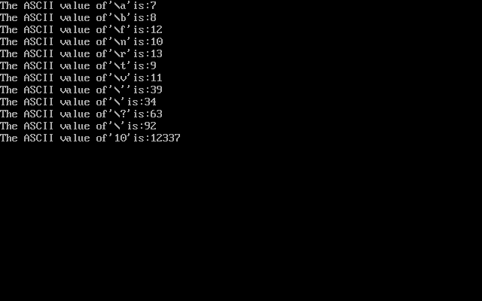

**2.**

**A program usually contains different types of data types (integer, float, character**

**etc.) and need to store the values being used in the program. C language is rich of data types. A C**

**programmer has to employ proper data type as per his requirements.**

**C has different data types for different types of data and can be broadly classified as:**

**1. Primary Data Types**

**2. Secondary Data Types**

**Primary Data Types:**

**Integer Data Types:**

**Integers are whole numbers with a range of values, range of values are machine dependent.**

**Generally an integer occupies 2 bytes memory space and its value range limited to -32768 to +32767**

**(that is, -215 to +215-1). A signed integer use one bit for storing sign and rest 15 bits for number.**

**To control the range of numbers and storage space, C has three classes of integer storage namely**

**short int, int and long int. All three data types have signed and unsigned forms. A short**

**int requires half the amount of storage than normal integer. Unlike signed integer, unsigned**

**integers are always positive and use all the bits for the magnitude of the number. Therefore, the**

**range of an unsigned integer will be from 0 to 65535. The long integers are used to declare a longer**

**range of values and it occupies 4 bytes of storage space.**

**Floating Point Data Types:**

**The float data type is used to store fractional numbers (real numbers) with 6 digits of precision.**

**Floating point numbers are denoted by the keyword float. When the accuracy of the floating point**

**number is insufficient, we can use the double to define the number. The double is same as float**

**Character Data Type:**

**Character type variable can hold a single character and are declared by using the keyword char. As**

**there are singed and unsigned int (either short or long), in the same way there are signed and**

**unsigned chars; both occupy 1 byte each, but having different ranges. Unsigned characters have**

**values between 0 and 255, signed characters have values from –128 to 127.**

**Void Type:**

**The void type has no values therefore we cannot declare it as variable as we did in case of integer**

**and float. The void data type is usually used with function to specify its type.**

**3.**

**In a C program , the smallest individual units are called C tokens.**

**C has Six types of tokens which are namely classified as follows.**

* **Keywords**
* **Identifiers**
* **Constants**
* **Strings**
* **Operators**
* **Special Symbols**

**4.**

**C supports some special backslash character constants that are used in output functions.**

**Each character represents one character although they consist of two characters.**

**These character combinations are called escape sequences.**

**\a,\b,\f,\n,\r,\t,\v are some of the backslash character constants**